Rotation of Rigid Bodies : Exercise 3 (Pulley Problems)
Example 1
Particles of mass m and 5m are attached one to each end of an inextensible string. The string passes over a small pulley, free to turn about a smooth horizontal axis. The pulley is to be modelled as a uniform circular disc of radius a and mass 4m and the axis passes through its centre of mass. Given that the string does not slide relative to the pulley, find the acceleration of the particles.
Example 2
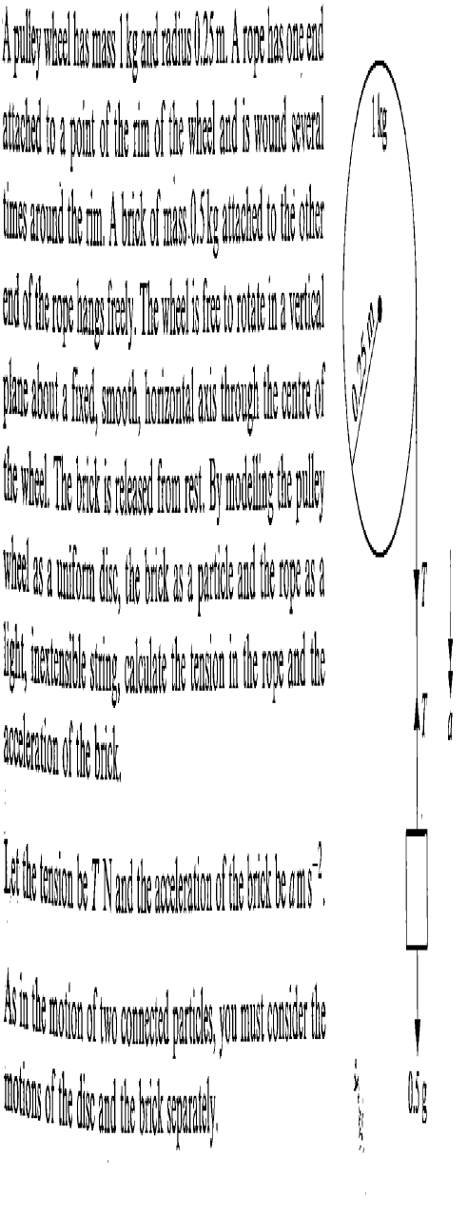

Exercise 3

1. A pulley of radius 20 cm has one of a string attached to a point on the rim. The string is wrapped round the pulley a number of times and it supports at its other end a particle of mass 1 kg, which hangs freely. Given that the moment of inertia of the pulley about the axis is 0.2 kg m² and that there is no resistance to motion, find the angular acceleration of the pulley when the system is released with the string taut and free part supporting the particle. [ 8 1/3 rads⁻² ]
2. A carousel has seats for 20 children at a distance of 2 metres from its axis of rotation, which is vertical. When unoccupied the motor can accelerate the carousel at 0.5 rad s⁻¹. When filled with children whose average mass is 40 kg the acceleration drops to 0.4 rad s⁻². Find the moment of inertia of the carousel about its axis, and the couple produced by the motor.
[12800 kg m², 6400 Nm]
3. A spinning top has the form of a uniform solid sphere of mass 0.5 kg and radius 4 cm, supported on a thin needle. It spins with the needle vertical, but when its angular speed drops to 40 rad s⁻¹ its motion becomes unstable. The top is set spinning at an angular speed of 100 rad s⁻¹, and goes on spinning for 2 minutes before the motion becomes unstable. Find the moment of the constant frictional couple slowing the top down. [ 1.6 x 10⁻⁴ Nm ]
4. A uniform disc of mass 5 kg and radius 12 cm is rotating at 20 rad s⁻¹. It is brought to rest in 0.6 seconds by friction from brake pads on each side of the disc 10 cm from the axis of rotation. Find the frictional force from each brake pad.
If the coefficient of friction is 0.8, what force must be applied normal to the surface of the disc to produce this deceleration? [ 6 N, 7.5 N ]

5. Two particles of equal mass m connected by an inextensible light string which passes over a pulley at the edge of a smooth horizontal table. If the pulley is free to rotate about its axis with a moment of inertia 4 mr² where r is its radius, find its angular acceleration when the system is released from rest. [ ]

6. A uniform solid cylinder of radius 0.5 m and mass 0.5 kg can rotate freely about a smooth, fixed, horizontal axis which coincides with the axis of cylinder. A light string passes over the cylinder in a vertical plane perpendicular to the axis of rotation. Particles of masses 0.25 kg and 0.5 kg are attached one to each end of the string and the system is released from rest. Assuming that the string does not slip on the cylinder and that neither particle has reached the cylinder, calculate the tensions in the two parts of the string and the angular acceleration of the cylinder.
[3.125 N, 3.75 N, 5 rad s⁻²]

